Exercise 4

Sending Packets
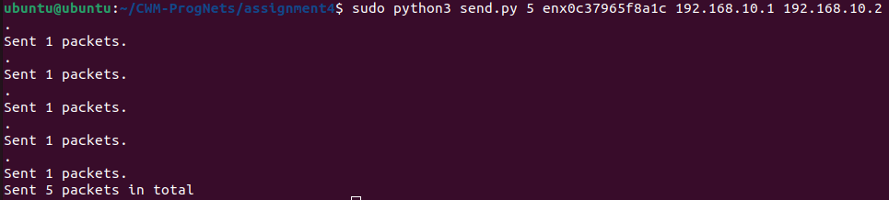
Receiving Packets (unblocked)

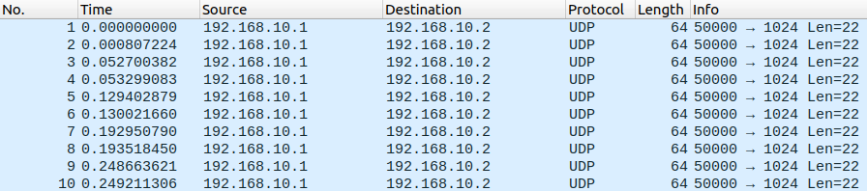
Receiving Packets (blocked)

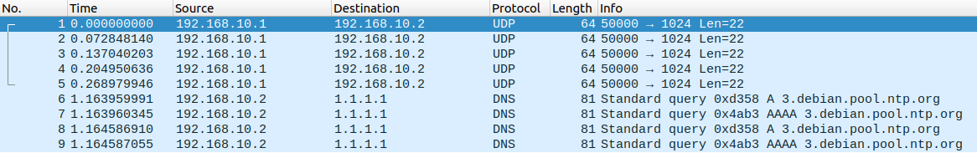
Using cwm file

